Analysis of Electric Vehicle available on the market
Abstract
Introduction: In recent years, the share of electrified vehicles in the new car sales has increased has been growing significantly. The main argument for this is that the electric vehicles has higher efficiency from onboard source to the wheels, referred as Tank To Wheel (TTW) efficiency. However, it is important to compare TTW efficiency for cars running on different types of fuel.
TTW is defined as a ratio energy required at the wheel level to the total energy of fuel used to produce the former. It depends on the driving conditions, types of fuel and constructive parameters of the vehicles. Based on the available data, this article provides information on the analysis of the average TTW efficiency of vehicles running on different fuel types.
Methodology: To find the TTW efficiency, the data in literature [1] is used. The data consists of the energy consumption per 100 km for the NEDC cycle for vehicles driving on different fuel types. To have proper comparison for different fuel vehicles, the consumption levels should be converted to kWh [2]. This can be performed using the energy content of the fuels (Petrol – 8.88 kWh/liter, Diesel – 10 kWh/liter, Natural gas – 12.3 kWh/kg,). The result of the conversion is shown in Fig.1.
The energy needed to run the vehicle on NEDC driving cycle was computed using the total resisting forces (aerodynamic, rolling and inertia) and shown in the Eq. 1 [3-5].
The average energy consumptions for each fuel type were also computed using the Eq. 2 and 3. The constant values of $C_{x}$, $A_{f}$ and $f_{r}$.are considered regardless the vehicle mass and the fuel type.

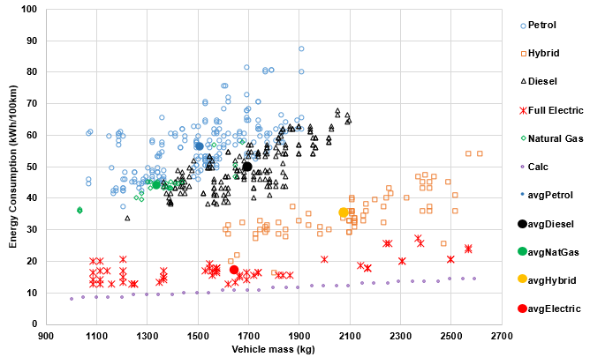
Fig.1: Energy consumption of the vehicles for 100km driving in the different fuel type
$R_{tot}=f_{r}⋅m_{i}⋅g+\frac{1}{2}⋅{⋅v}^{2}⋅ C_{x}⋅ A_{f}+m_{i}⋅a$ (1)
$M_{avg}=\frac{∑(m_{i})}{n}$ (2)
${EC}_{avg}= \frac{∑({ec}_{i})}{n}$ (3)

Where, $M_{avg}$ – average mass of the vehicle, [kg]; $m_{i}$ – mass of the vehicle for the same fuel type, [kg]; ${EC}_{avg}$ – average energy consumption of the vehicle, [kWh]; ${ec}_{i }$– energy consumption of the vehicle for the same fuel type, [kg]; n - number of vehicles, $R_{tot}$ - total resistance to vehicle motion, [N]; $a$ – acceleration, [m/s²]; $v$ – velocity, [m/s]; $C_{x}$ – aerodynamic drag coefficient, [N]; $A_{f}$ – frontal area of the vehicle, [m²]; - mass density of the air, [kg/m³]; $f_{r}$ – tire rolling resistance coefficient.
As Fig.1 depicts, the average energy consumed by vehicles driving on different type of fuel are: for a petrol engine – 56.5 kWh/100km, a diesel engine – 50.1kWh/100km, a hybrid – 35 kWh/100km, full electric – 17.3 kWh/100km and natural gas – 43.5 kWh/100km. The average energy needed to run the vehicle on the NEDC for the given average mass $M_{avg}$ of the vehicle are equal to: petrol engine – 9.9 kWh/100km, diesel engine – 10.68 kWh/100km, hybrid – 12.28 kWh/100km, full electric – 10.5 kWh/100km and natural gas – 9.2 kWh/100km. The average TTW efficiency is determined by the ratio of average energy required to total energy consumed. The results for the average efficiencies for different fuel types are shown in Fig.2.

Results:
As can be seen from the Fig.1, the consumed energy increases with increasing the vehicle mass. The Fig.2 shows that the full electric vehicle has the highest TTW efficiency reaching almost 60%. This could be due to high conversion efficiency of the electric motor (around 90%) and less number of elements in the drivetrain path. The hybridization allows around 15% efficiency improvement over the vehicles with conventional powertrains.

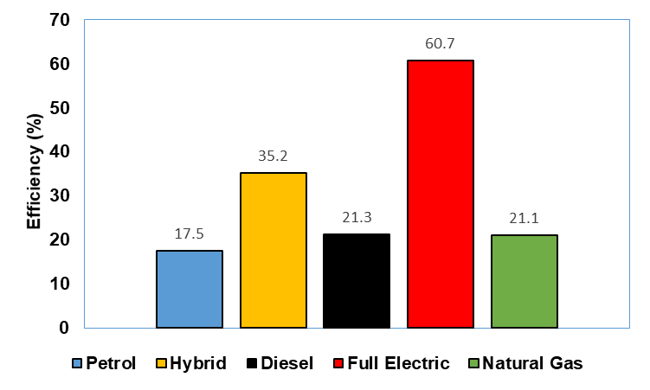
Fig.2: Efficiency of the vehicles driving in the different fuel type

Discussion/Conclusion:

The average TTW efficiency for the vehicles with different fuel types are considered. The catalog of the commercially available cars are used to retrieve the data for energy consumption. The analysis show that the average TTW for the full electric vehicle is the highest due to high efficiency of the energy conversion of the electric motor. However, the average TTW efficiency values should be considered with caution as a Well To Tank (WTT) efficiency should also be taken into account. Depending on the production origin of the fuel, WTT can differ from one country to another.

References:
- Leitfaden über den Kraftstoffverbrauch, die CO2-Emissionen und den Stromverbrauch aller neuen Personenkraftwagenmodelle, die in Deutschland zum Verkauf angeboten werden Ausgabe 2019 (https://www.datgroup.com/leitfaden/LeitfadenCO2.pdf)
- Ole Kolb, Stefan Siegemund Study on the Implementation of Article 7(3) of the “Directive on the Deployment of Alternative Fuels Infrastructure” – Fuel Price Comparison January – 2017(https://ec.europa.eu/transport/sites/transport/files/2017-01-fuel-price-comparison.pdf)
- L.Guzella, A.Amstutz The QSS Toolbox Manual June 2005 (https://vdocuments.mx/qss-tb-manual.html)
- Onori, S., Serrao, L., & Rizzoni, G. (2016). Hybrid electric vehicles: Energy management strategies (pp. 25-28). London: Springer.
- Genta, G., & Morello, L. (2019). The automotive chassis: volume 2: system design. Springer Nature.

