DURABILITY ANALYSES OF PROTON EXCHANGE MEMBRANE FUEL CELLS

ABSTRACT. Vehicle manufacturers have taken steps to reduce the environmentally harmful exhaust gas emissions from automobiles. Various technologies are implemented to improve fuel efficiency of the vehicle and reduce the emissions of the exhaust gases. One of such technologies is so called, hydrogen powered automobiles. One of the bottlenecks hindering the usage of polymer electrolyte membrane fuel cell technology in automotive applications is the highly load-sensitive degradation of the cell components.
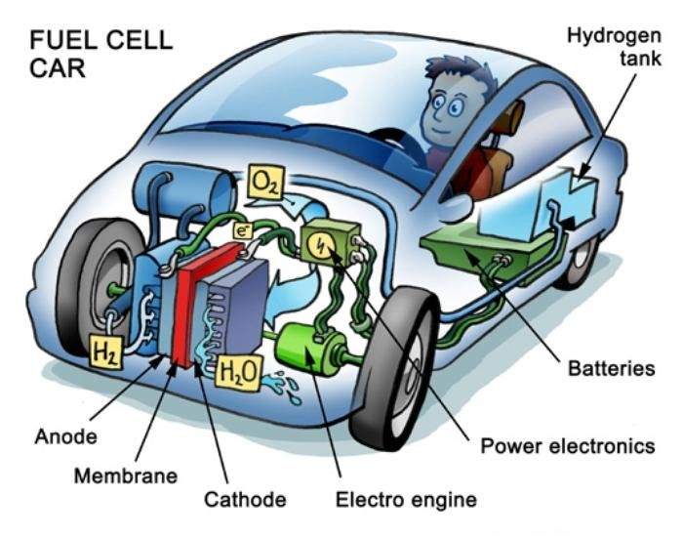
Schematic of a PEMFC MEA fed with hydrogen or oxygen (or air)
The cell failure cases reported in thesis show localized cell component degradation, mainly caused by flow-field dependent non-uniform distribution of reactants. The existing methodologies for diagnostics of localized cell failure are either invasive or require sophisticated and expensive apparatus. In this study, with the help of multiscale simulation framework, a single polymer electrolyte membrane fuel cell (PEMFC) model is exposed to a standardized drive cycle provided by a system model of a fuel cell car. A 2D multi-physics model of the PEMFC is used to investigate catalyst degradation due to spatio-temporal variations in the fuel cell state variables under highly transient load cycles. A three-step (extraction, oxidation, dissolution) model of platinum loss in the cathode catalyst layer is used to investigate the cell performance degradation due to the consequent reduction in the electro-chemical active surface area (ECSA). By using a time-upscaling methodology, we present a comparative prediction of cell end-of-life (EOL) under different driving of New European Driving Cycle (NEDC) and Worldwide Harmonized Light Vehicles Test Cycle (WLTC)
